**Assignment -1**

**Name : Gourav Rana**

**Registration no. 2105105015**

**Branch : MCA**

**Subject : Programing using JAVA**

**Semester : 3**

**Program 1**

**//1. Write a java program to print your biodata**

public class Qes_1 {

public static void main(String[] args) {

System.out.println("_________My Bio Data________");

System.out.println("-----------------------------");

System.out.println("1.Name :- Gourav Rana");

System.out.println("2.Branch :- MCA");

System.out.println("3.regd.no. :- 2105105025");

System.out.println("4.roll no. :- 404016");

System.out.println("5.Adress :- Athmallik, Angul");

}

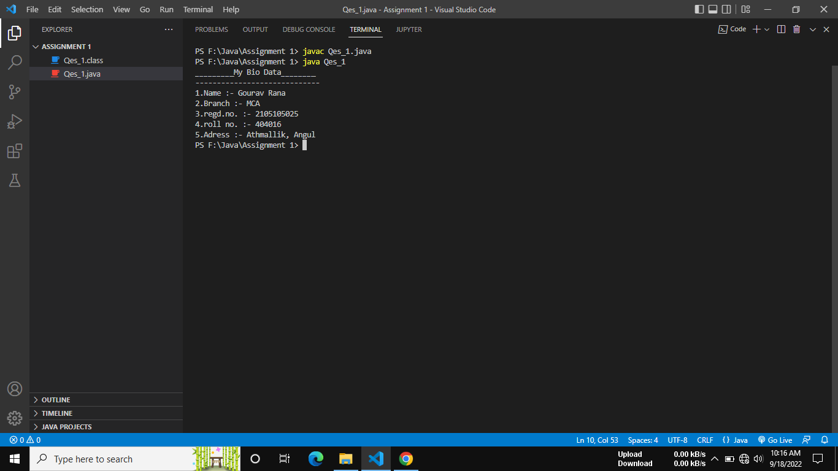}

**Program 2**

**//2. Write a java program to find simple interest**.

public class Qes_2 {

public static void main(String[] args) {

int p=10000;

int r=10;

int t=3;

int i;

System.out.println("The principal amount is : "+p);

System.out.println("Rate of interest is : "+r);

System.out.println("The time period is : "+t);

i=p*t*r/100;

System.out.println("===================");

System.out.println("simple interest is : "+i);

}

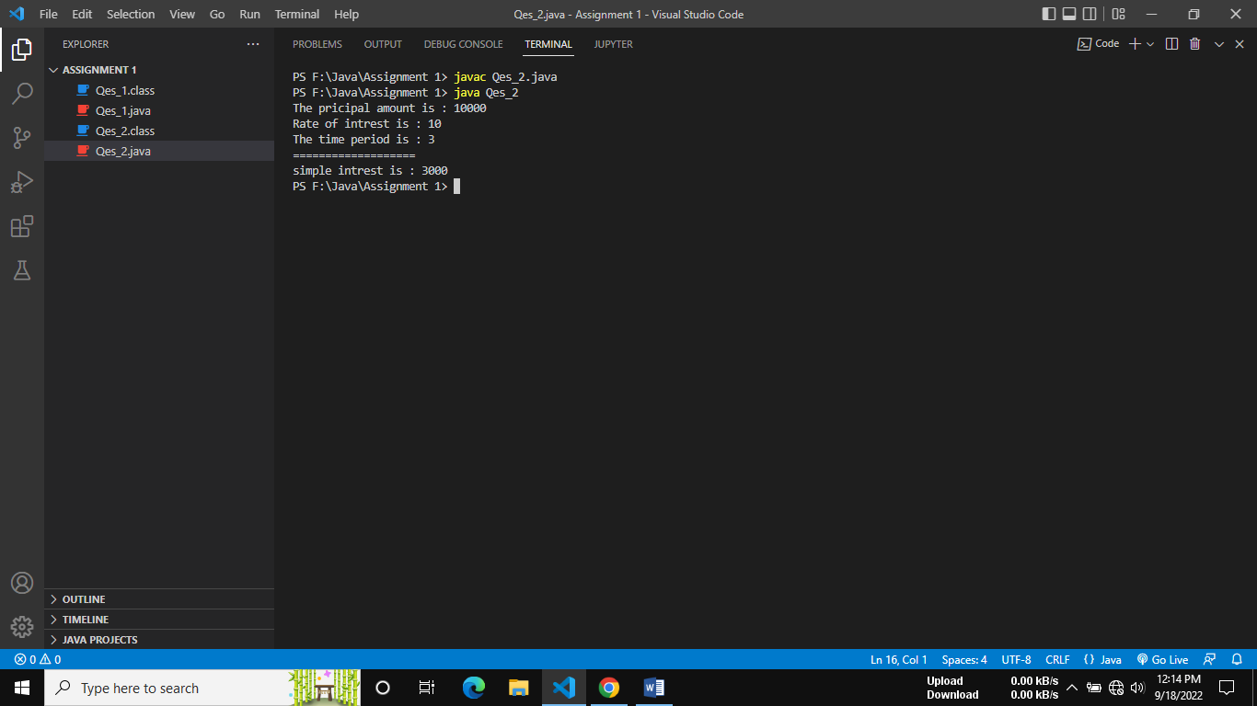}

**Program 3**

**//3. Write a java program for temperature conversion**

public class Qes_3 {

public static void main(String[] args) {

int c = 38;

int new_f = ((c * 9) / 5) + 32;

System.out.println("Celsius is " + c + " convert to Fahrenheit is :" + new_f);

int f = 108;

int new_c = ((f - 32) * 5) / 9;

System.out.println("Fahrenheit is " + f + " convert to Celsius is : " + new_c);

}

}

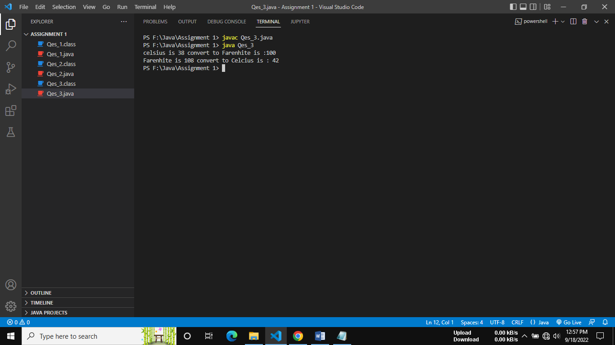

**Program 5.1**

**//5.1 Sum of all digits of any 4 digit numbers**

public class Qes_5_1 {

public static void main(String[] args) {

int sum=0;

int x=4653;

System.out.println("The entered digit is : "+x);

sum=sum+(x%10)+(x/10)%10+(x/100)%10+(x/1000)%1000;

System.out.println("Sum all 4 digit number = "+sum);

}

}

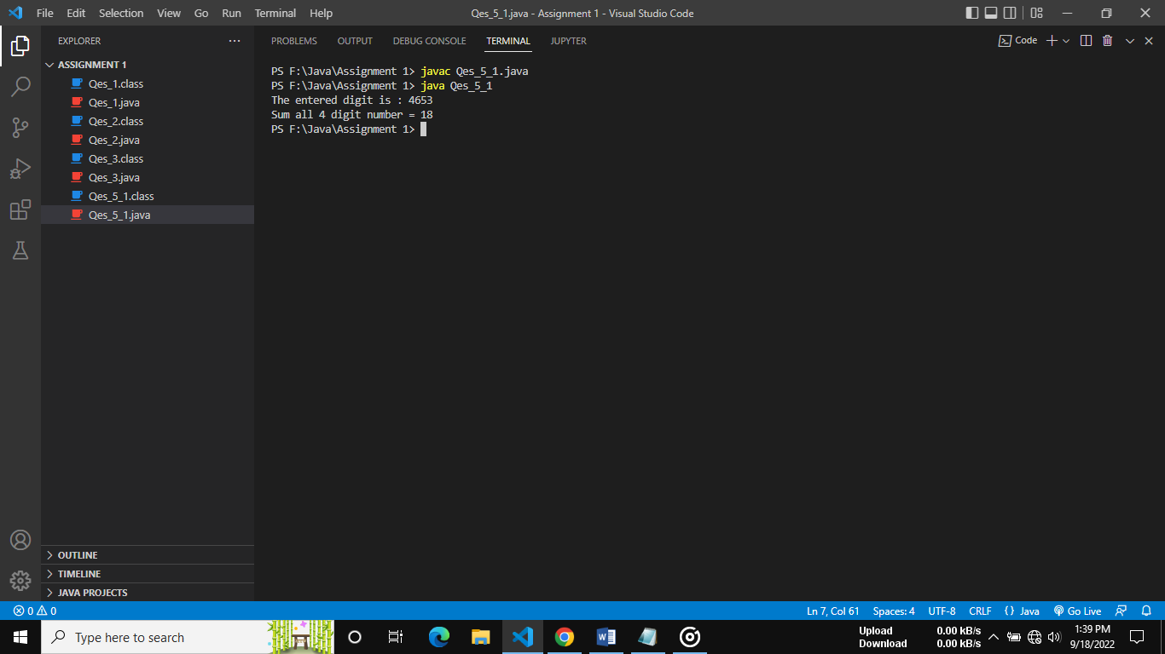

**Program 5.2**

**//find the face value and position value of any 4 digit number**

public class Qes_5_2 {

    public static void main(String[] args) {

        int num=3214;

        int num1,num2,num3,num4;

        num1=num/1000;num=num%1000;

        num2=num/100;num=num%100;

        num3=num/10;num=num%10;

        num4=num;

        System.out.println("Face Value of "+num1+" is "+num1);

        System.out.println("Face Value of "+num2+" is "+num2);

        System.out.println("Face Value of "+num3+" is "+num3);

        System.out.println("Face Value of "+num4+" is "+num4);

        num=3214;

        num1=num/1000;num=num%1000;num1=num1*1000;

        num2=num/100;num=num%100;num2=num2*100;

        num3=num/10;num=num%10;num3=num3*10;

        num4=num;

        System.out.println("Place Value of "+num1+" is "+num1);

        System.out.println("Place Value of "+num2+" is "+num2);

        System.out.println("Place Value of "+num3+" is "+num3);

        System.out.println("Place Value of "+num4+" is "+num4);

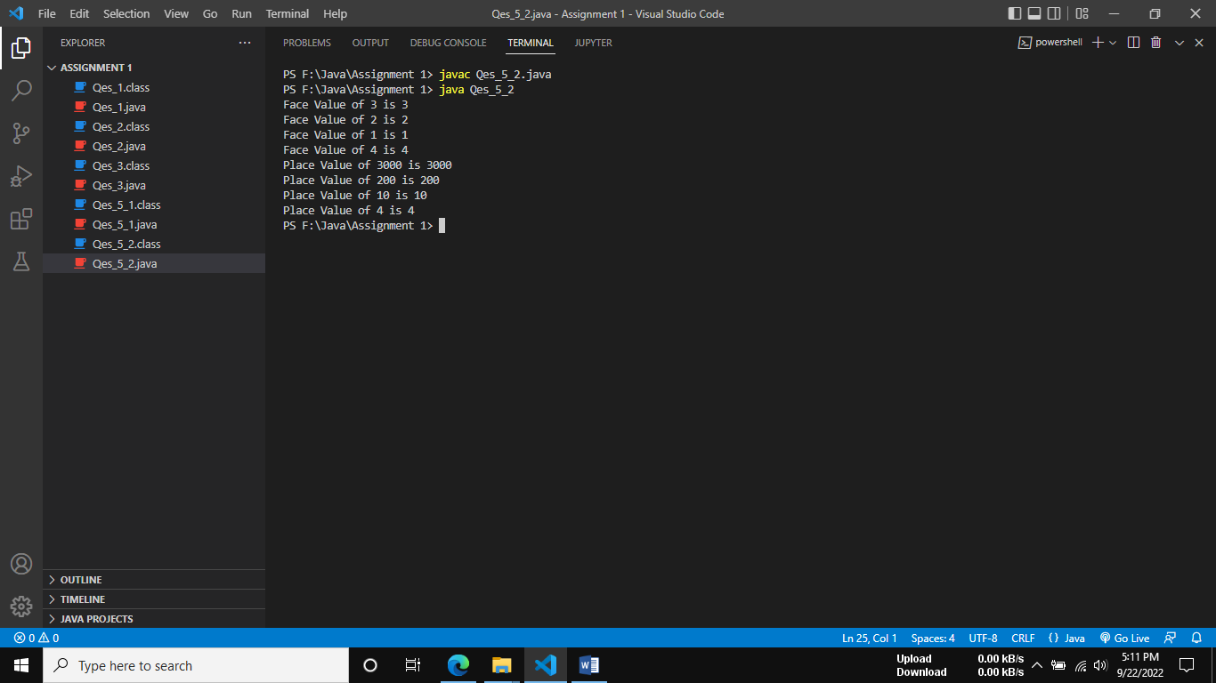    }

}

**Program 5.4**

**/*Sum of product of consecutive digits of any 4 digit number? Supoose**

**num=1234 then output= 4*3+3*2+2*1 */**

public class Qes_5_4 {

    public static void main(String[] args) {

        int num=1234;

        int sop=0;//sop :sum of Product

        sop=((num %10)*((num/10)%10))+ (((num/10)%10)*((num/100)%10))+(((num/100)%10)*((num/1000)%10));

        System.out.println("Sum of product of consecutive digits : "+sop);

    }

}

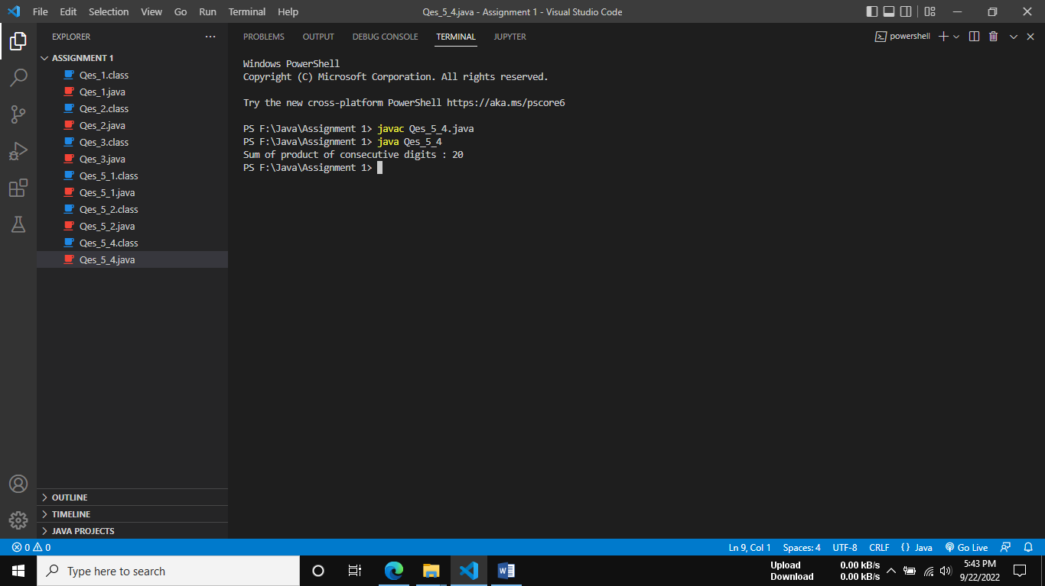

**Program 5.5**

**//find sum of product of corresponding digits of two any 4 digit**

**//number Such as n=1234 m=7896 output=6*4+9*3+8*2+7*1**

public class Qes_5_5 {

    public static void main(String[] args) {

       int n=1234;

       int m=5678;

       int sum=0;

       sum=((m%10)*(n%10))+((m/10)%10)*((n/10)%10)+((m/100)%10)*((n/100)%10)+((m/1000)%10)*((n/1000)%10) ;

       System.out.println("Sum of product of corresponding digits of two any 4 digit is : "+sum);

    }

}

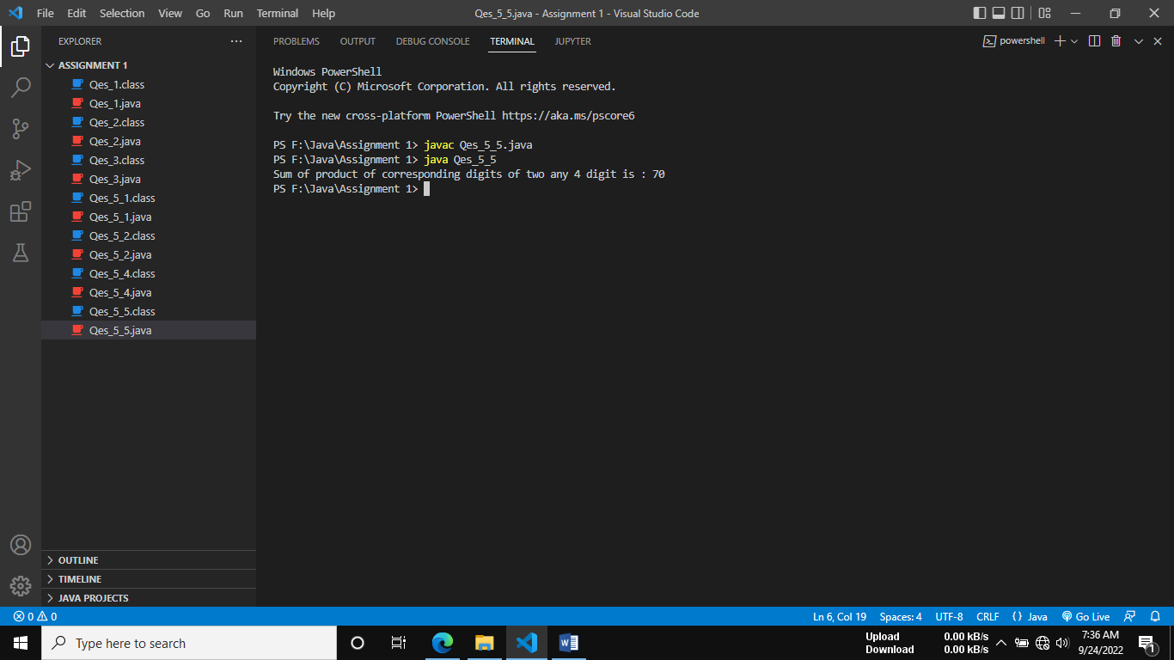

**Program 5.6**

**//find bitwise and , or , and xor of 2nd and 4th digit of any 4 digit number**

public class Qes_5_6 {

    public static void main(String[] args) {

       int num=1234;

       int m,n,temp;

       m=((num/10)%10);

       n=((num/1000)%10);

       temp=m|n;

       System.out.println("Bitwise OR value of 2nd :"+m+" and"+" 4th "+n+" is = "+temp);

       temp=m&n;

       System.out.println("Bitwise AND value of 2nd :"+m+" and"+" 4th "+n+" is = "+temp);

       temp=m^n;

       System.out.println("Bitwise XOR value of 2nd :"+m+" and"+" 4th "+n+" is = "+temp);

    }

}

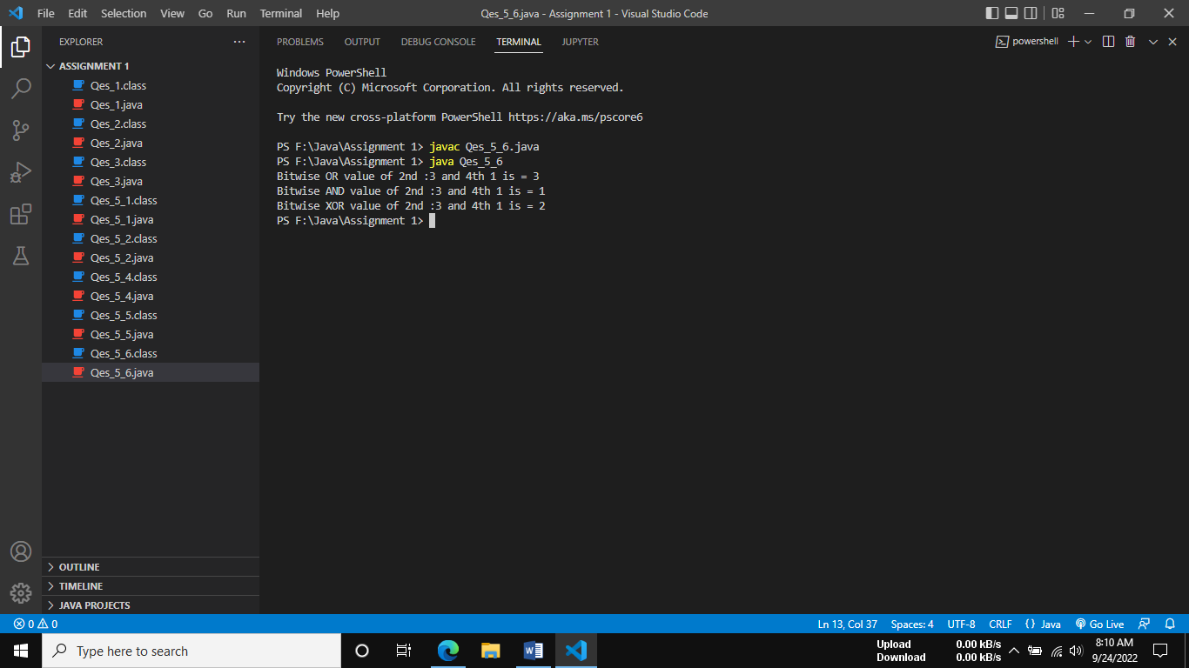

**Program 5.7**

**/*Find left shit, right shift and zero fill of summation of all digits of any**

**4 digit number and it will be shifted by 3rd digit of any 4 digit**

**number */**

public class Qes_5_7 {

    public static void main(String[] args) {

        int sum,num,d1,d2,d3,d4;

        num=3456;

        d1 = num / 1000;

        d2 = num / 100 % 10;

        d3 = num / 10 % 10;

        d4 = num % 10;

        sum = d1 + d2 + d3 + d4;

        System.out.println("The number is: " + num);

        System.out.println("The Sum of the digits is: " + sum);

        System.out.println("Left shift upto " + d3 + " to sum is: " + (sum << d3));

        System.out.println("Right shift upto " + d3 + " to sum is: " + (sum >> d3));

        System.out.println("Right shift and zero fill upto " + d3 + " to sum is: " + (sum >>> d3));

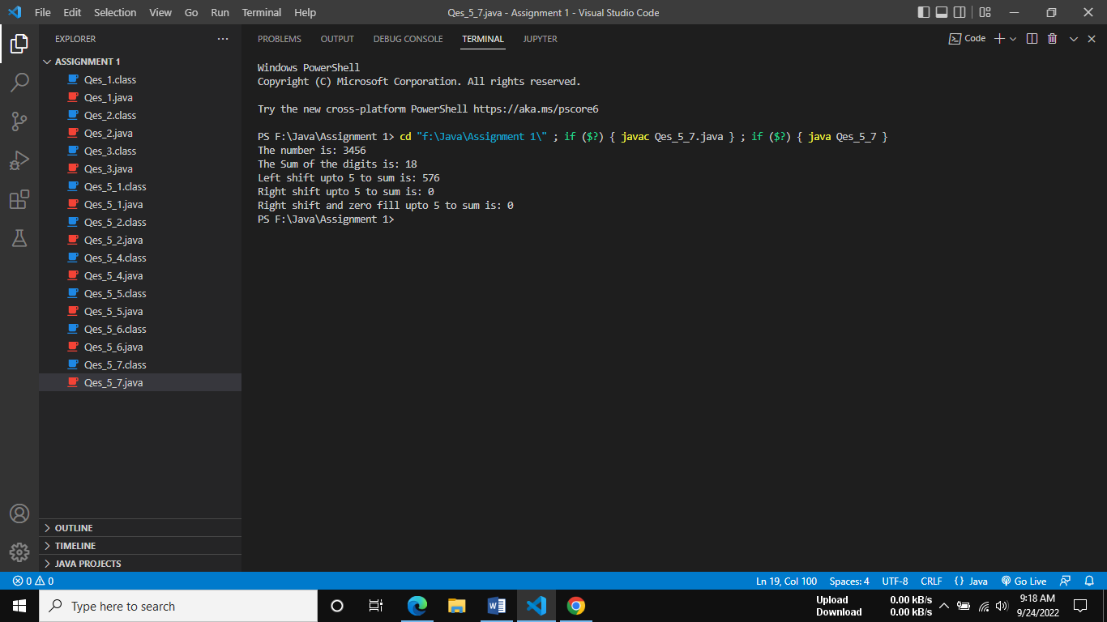    }

}

**Program 6.a**

**/*Sum of all even digits of any 4 digit number */**

public class Qes_6_a {

    public static void main(String[] args) {

        int num, d1, d2, d3, d4;

        int sum = 0;

        num = 1548;

        d1 = num / 1000;

        d2 = num / 100 % 10;

        d3 = num / 10 % 10;

        d4 = num % 10;

        sum = sum+(d1 % 2 == 0 ? d1 : 0);

        sum =  sum +(d2 % 2 == 0 ? d2 : 0);

        sum =  sum +(d3 % 2 == 0 ? d3 : 0);

        sum = sum +(d4 % 2 == 0 ? d4 : 0);

        System.out.println("The number is: "+num);

        System.out.println("Sum of the all even digits of the number is: "+sum);

    }

}

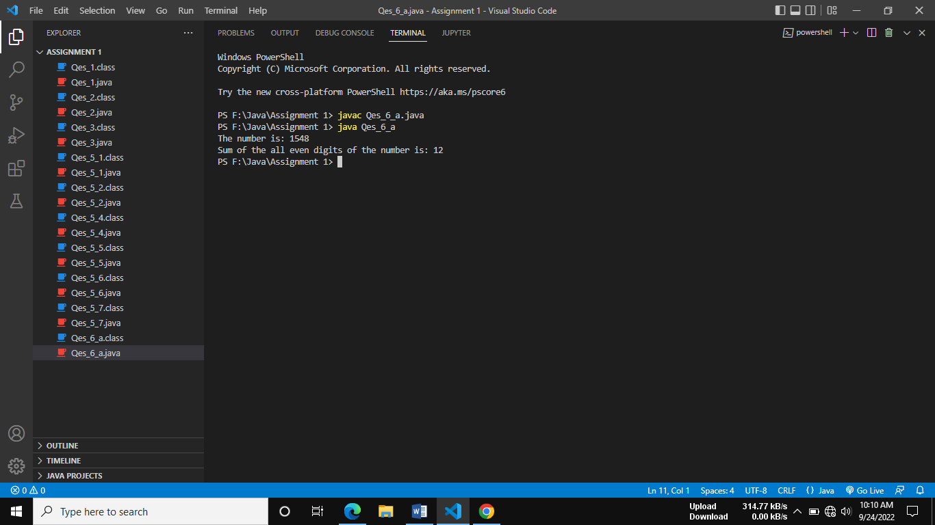

**Program 6.b**

**/*Sum of all odd digits of any 4 digit number */**

public class Qes_6_b {

    public static void main(String[] args) {

        int num, d1, d2, d3, d4;

        int sum = 0;

        num = 1548;

        d1 = num / 1000;

        d2 = num / 100 % 10;

        d3 = num / 10 % 10;

        d4 = num % 10;

        sum = sum+(d1 % 2 != 0 ? d1 : 0);

        sum =  sum +(d2 % 2 != 0 ? d2 : 0);

        sum =  sum +(d3 % 2 != 0 ? d3 : 0);

        sum = sum +(d4 % 2 != 0 ? d4 : 0);

        System.out.println("The number is: "+num);

        System.out.println("Sum of the all odd digits of the number is: "+sum);

}

}

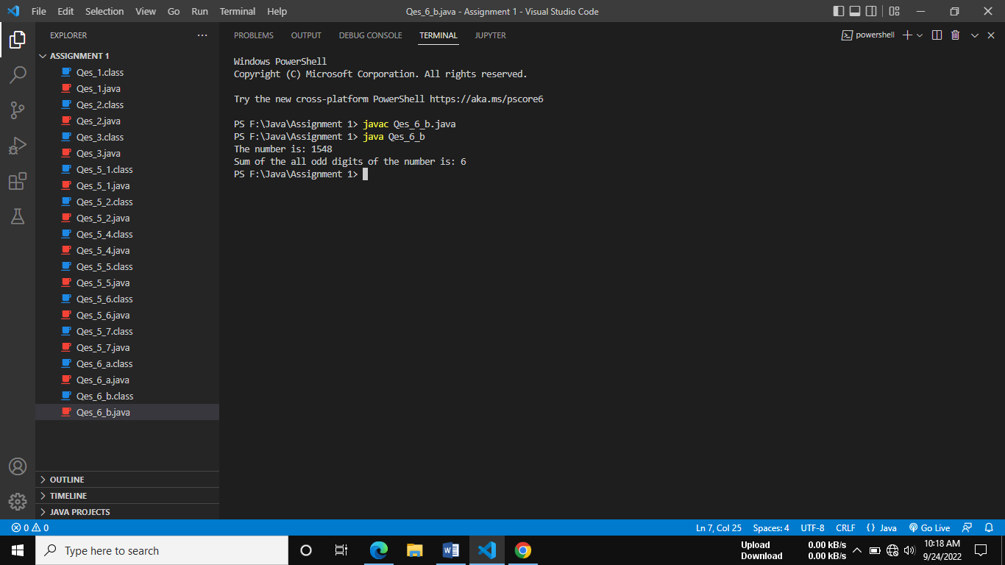

**Program 6.c**

**/\***

**\* Difference between average of all even digits except divisible by 4 and**

**\* avearge of all odd digits except divisble by 3 of any 4 digit number**

**\*/**

import java.util.Scanner;

public class Qes_6_c {

    public static void main(String[] args) {

      int num,d1,d2,d3,d4;

      System.out.println("Enter a 4 digit number : ");

      Scanner sc=new Scanner(System.in);

      num=sc.nextInt();

sc.close();

      int avgEvenCount=0,avgOddCount=0;

      float diff,avgEven=0,avgOdd=0;

      d1=num/1000;

      d2=num/100%10;

      d3=num/10%10;

      d4=num%10;

//Average of all even digits except divisible by 4

avgEven = avgEven+((d1%2==0)&&(d1%4 !=0)? d1:0);

avgEvenCount=avgEvenCount +((d1%2==0)&&(d1%4 !=0) ? 1:0);

avgEven = avgEven+((d2%2==0)&&(d2%4 !=0)? d2:0);

avgEvenCount=avgEvenCount +((d2%2==0)&&(d2%4 !=0) ? 1:0);

avgEven = avgEven+((d3%2==0)&&(d3%4 !=0)? d3:0);

avgEvenCount=avgEvenCount +((d3%3==0)&&(d3%3 !=0) ? 1:0);

avgEven = avgEven+((d4%2==0)&&(d4%4 !=0)? d4:0);

avgEvenCount=avgEvenCount +((d4%2==0)&&(d4%4 !=0) ? 1:0);

//Average of all odd digits except divisible by 3

avgOdd = avgOdd +((d1%2!=0)&&(d1%3!=0)? d1:0);

avgOddCount=avgOddCount +((d1%2!=0)&&(d1%3!=0)? 1:0);

avgOdd = avgOdd +((d2%2!=0)&&(d2%3!=0)? d2:0);

avgOddCount=avgOddCount +((d2%2!=0)&&(d2%3!=0)? 1:0);

avgOdd = avgOdd +((d3%2!=0)&&(d3%3!=0)? d3:0);

avgOddCount=avgOddCount +((d3%2!=0)&&(d3%3!=0)? 1:0);

avgOdd = avgOdd +((d4%2!=0)&&(d4%3!=0)? d4:0);

avgOddCount=avgOddCount +((d4%2!=0)&&(d4%3!=0)? 1:0);

avgEven=avgEven/avgEvenCount;

avgOdd=avgOdd/avgOddCount;

diff=avgEven-avgOdd;

System.out.println("Entered number is : "+num);

System.out.println("thee diffrence is : "+diff);

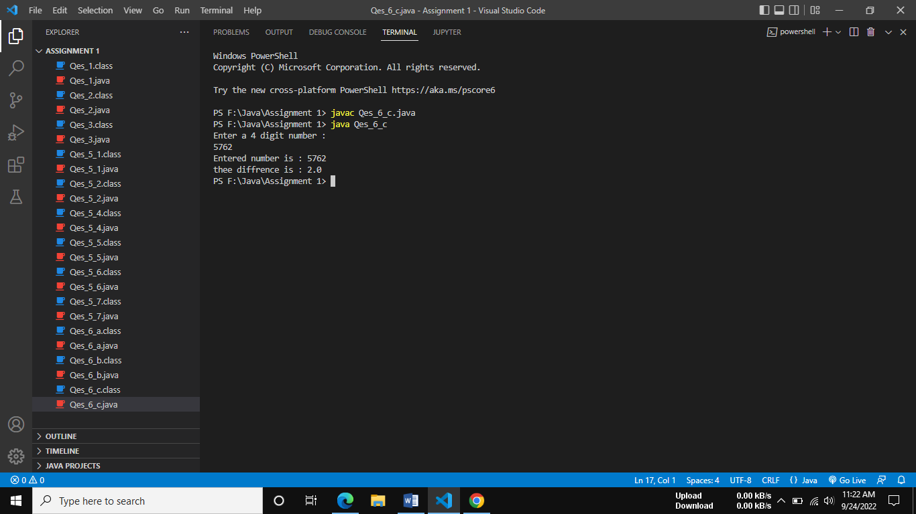    }

}

**Program 6.d**

**/*Sum of product of consecutive even digits of any 4 digit number? Supoose**

**num=1624 then output= 4*2+2*6 */**

public class Qes_6_d {

public static void main(String[] args) {

int num, sum;

int d1, d2, d3, d4;

num = 1624;

sum = 0;

d1 = num / 1000;

d2 = num / 100 % 10;

d3 = num / 10 % 10;

d4 = num % 10;

sum =sum+ ((d1 % 2 == 0 && d2 % 2 == 0 ) ? d1 * d2 : 0);

sum = sum + ((d2 % 2 == 0 && d3 % 2 == 0 ) ? d2 * d3 : 0);

sum = sum +((d3 % 2 == 0 && d4 % 2 == 0 ) ? d3 * d4 : 0);

System.out.println("Sum of product of consecutive even digits: "+sum);

}

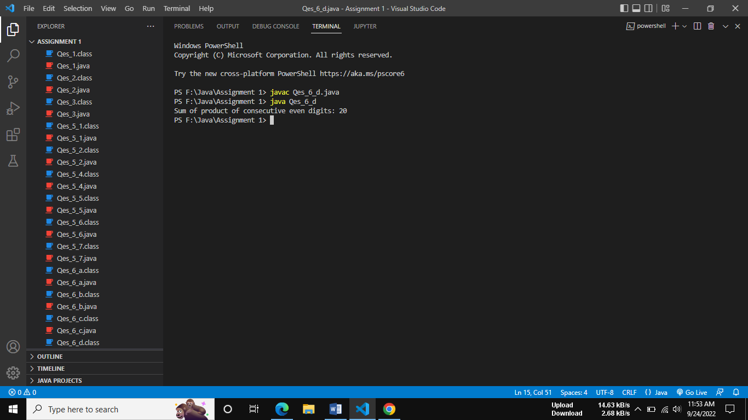}

**Program 6.e**

**/* Sum of product of consecutive odd digits of any 4 digit number? Supoose**

**num=1356 then output= 5*3+ 3*1**

**\*/**

public class Qes_6_e {

        public static void main(String[] args) {

            int num, sum;

            int d1, d2, d3, d4;

            num = 1356;

            sum = 0;

            d1 = num / 1000;

            d2 = num / 100 % 10;

            d3 = num / 10 % 10;

            d4 = num % 10;

            sum =sum+ ((d1 % 2 != 0 && d2 % 2 != 0 ) ? d1 * d2 : 0);

            sum = sum + ((d2 % 2 != 0 && d3 % 2 != 0 ) ? d2 * d3 : 0);

            sum = sum +((d3 % 2 != 0 && d4 % 2 != 0 ) ? d3 * d4 : 0);

            System.out.println("Sum of product of consecutive odd digits: "+sum);

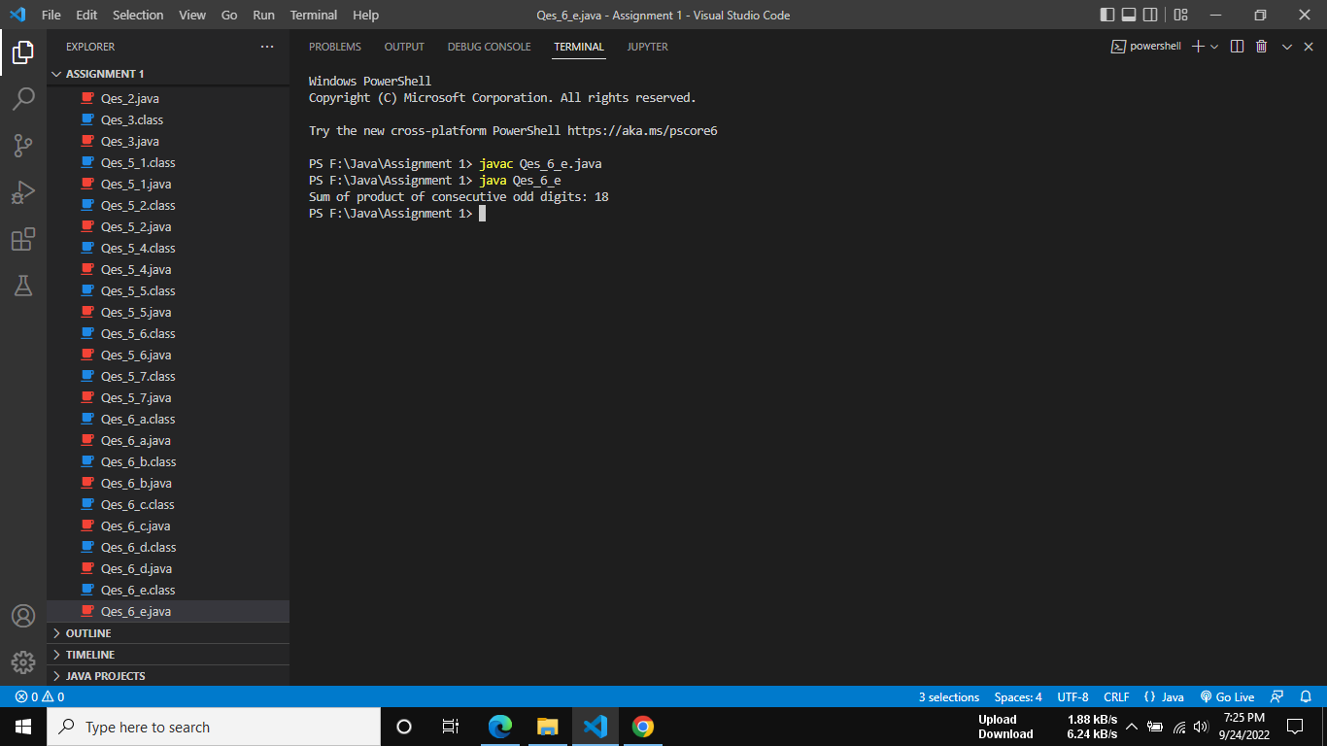    }

}

**Program 6.f**

**/* Difference between Sum of product of consecutive even digits except 2 and 6 and Sum of product of consecutive odd digits except 3 and 7 of any 4 digit number */**

import java.util.*;

public class Qes_6_f {

    public static void main(String[] args) {

        Scanner sc = new Scanner(System.in);

        int num, d1, d2, d3, d4, sumOdd, sumEven, diff;

        System.out.println("Enter the 4 digit Number: ");

        num = sc.nextInt();

        diff = 0;

        sumOdd = 0;

        sumEven = 0;

        d1 = num / 1000;

        d2 = num / 100 % 10;

        d3 = num / 10 % 10;

        d4 = num % 10;

 sumEven += ( d1 % 2 == 0 && d1 != 2 && d1 != 6 ) && ( d2 % 2 == 0 && d2 != 2 && d2 != 6 ) ? d1 * d2 :0;

 sumEven += ( d2 % 2 == 0 && d2 != 2 && d2 != 6 ) && ( d3 % 2 == 0 && d3 != 2 && d3 != 6 ) ? d2 * d3:0;

sumEven += ( d3 % 2 == 0 && d3 != 2 && d3 != 6 ) && ( d4 % 2 == 0 && d4 != 2 && d4 != 6 ) ? d3 * d4 : 0;

  sumOdd += ( d1 % 2 != 0 && d1 != 3 && d1 != 7 ) && ( d2 % 2 != 0 && d2 != 3 && d2 != 7 ) ? d1 * d2 :0;

    sumOdd += ( d2 % 2 != 0 && d2 != 3 && d2 != 7 ) && ( d3 % 2 != 0 && d3 != 3 && d3 != 7 ) ? d2 * d3:0;

    sumOdd += ( d3 % 2 != 0 && d3 != 3 && d3 != 7 ) && ( d4 % 2 != 0 && d4 != 3 && d4 != 7 ) ? d3 * d4 :0;

        diff = sumEven - sumOdd;

        System.out.println("The Product of sum of all Even Digits: "+sumEven);

        System.out.println("The Product of sum of all Odd Digits: "+sumOdd);

        System.out.println("The difference is: "+diff);

        sc.close();

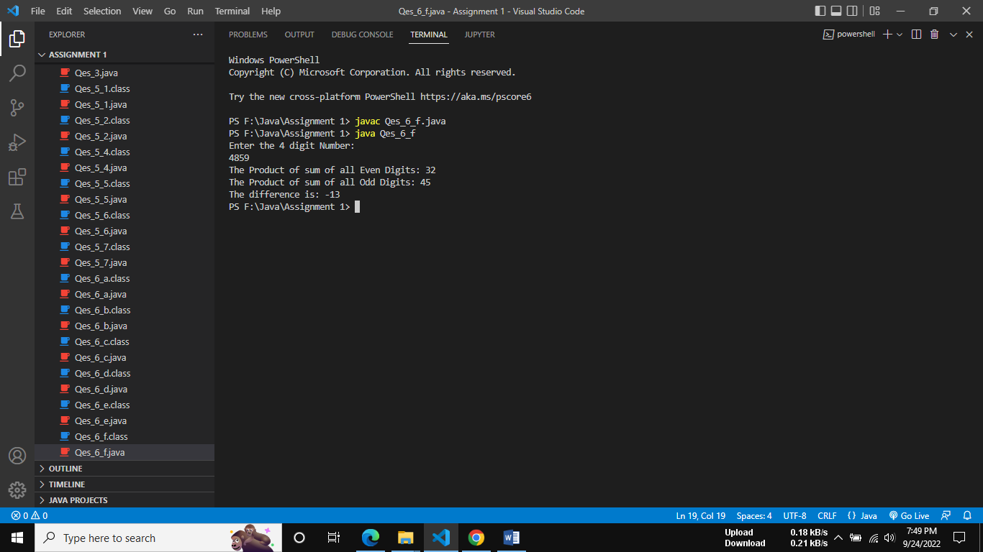    }

}

**Program 6.g**

**/* Write a java program to find sum of product of corresponding even digits of first any digit number and corresponding odd digit of any 4 digit number Such as n=1234 m=4567 output=4*7+2*5 */**

import java.util.Scanner;

public class Qes_6_g {

    public static void main(String[] args) {

        Scanner sc=new Scanner(System.in);

        int n,m,n1,n2,n3,n4,m1,m2,m4,m3;

        int sum;

        System.out.println("Enter first 4 digit number : ");

        n=sc.nextInt();

        System.out.println("Enter second 4 digit number : ");

        m=sc.nextInt();

sum=0;

    n1=n/1000;

    n2=n/100 % 10;

    n3=n/10 % 10;

    n4=n%10;

    m1=m/1000;

    m2=m/100 %10;

    m3=m/10 %10;

    m4=m %10;

    sum += (n1 %2 == 0) && (m1 %2 != 0) ? n1 * m1 : 0;

    sum += (n2 %2 == 0) && (m2 %2 != 0) ? n2 * m2 : 0;

    sum += (n3 %2 == 0) && (m3 %2 != 0) ? n3 * m3 : 0;

    sum += (n4 %2 == 0) && (m4 %2 != 0) ? n4 * m4 : 0;

    System.out.println("The sum of number and corresponding value is: "+sum);

    sc.close();

    }

}

